**WEEK-2**

**PL/SQL Exercises:**

**Exercise-3: Stored Procedures**

**1.Creating Tables:**

CREATE TABLE savings_accounts (

    AccountID NUMBER PRIMARY KEY,

    CustomerName VARCHAR2(50),

    Balance NUMBER

);

CREATE TABLE employees (

    EmployeeID NUMBER PRIMARY KEY,

    Name VARCHAR2(50),

    Department VARCHAR2(30),

    Salary NUMBER

);

CREATE TABLE accounts (

    AccountNumber NUMBER PRIMARY KEY,

    AccountHolder VARCHAR2(50),

    Balance NUMBER

);

**Output:**

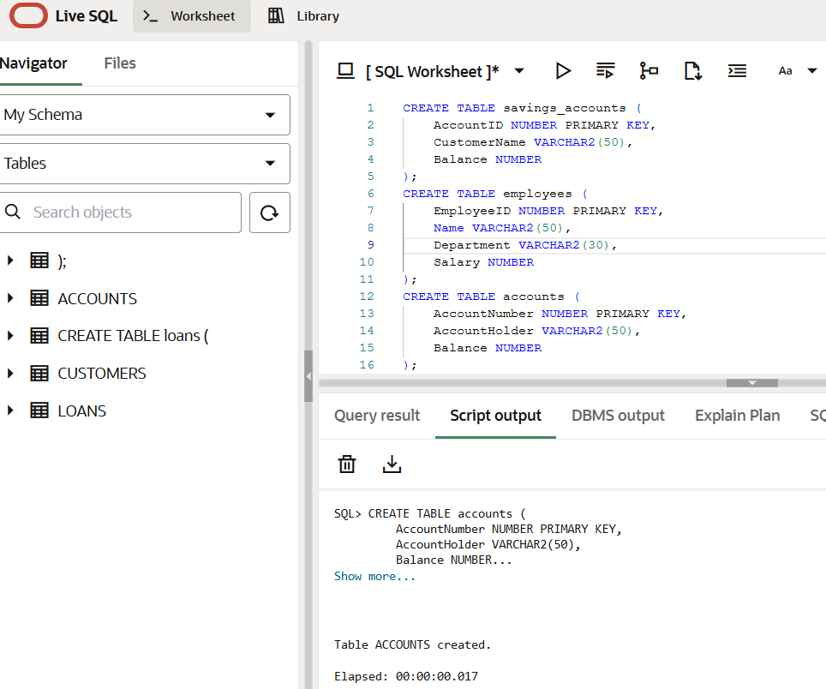

**2.Inserting Values:**

INSERT INTO savings_accounts VALUES (1, 'Alice', 10000);

INSERT INTO savings_accounts VALUES (2, 'Bob', 15000);

INSERT INTO savings_accounts VALUES (3, 'Charlie', 5000);

INSERT INTO employees VALUES (101, 'David', 'IT', 60000);

INSERT INTO employees VALUES (102, 'Eva', 'Finance', 65000);

INSERT INTO employees VALUES (103, 'Frank', 'IT', 58000);

INSERT INTO accounts VALUES (111, 'George', 20000);

INSERT INTO accounts VALUES (222, 'Helen', 10000);

COMMIT;

**Output:**

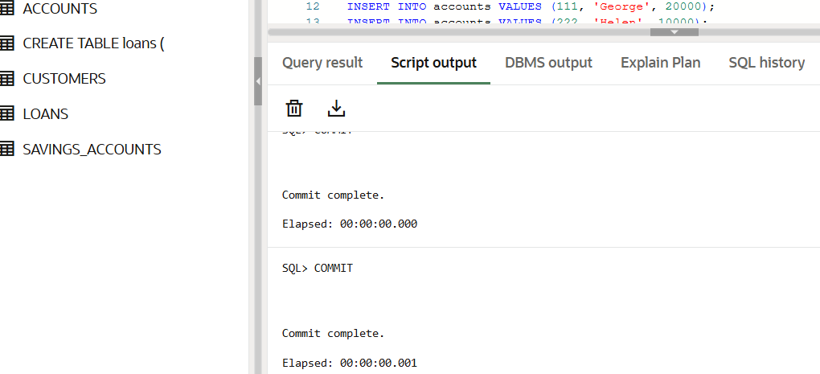

**3.Process Monthly Interest:**

CREATE OR REPLACE PROCEDURE ProcessMonthlyInterest IS

BEGIN

    FOR acc IN (SELECT AccountID, Balance FROM savings_accounts) LOOP

        UPDATE savings_accounts

        SET Balance = Balance + (Balance * 0.01)

        WHERE AccountID = acc.AccountID;

    END LOOP;

END;

/

**Output:**

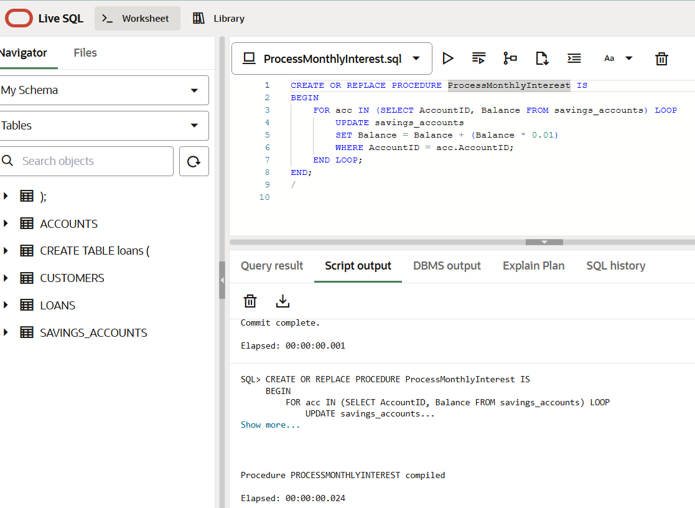

**4.Update Employee Bonus:**

CREATE OR REPLACE PROCEDURE UpdateEmployeeBonus (

    dept_name IN VARCHAR2,

    bonus_pct IN NUMBER

) IS

BEGIN

    UPDATE employees

    SET Salary = Salary + (Salary * bonus_pct / 100)

    WHERE Department = dept_name;

END;

/

**Output:**

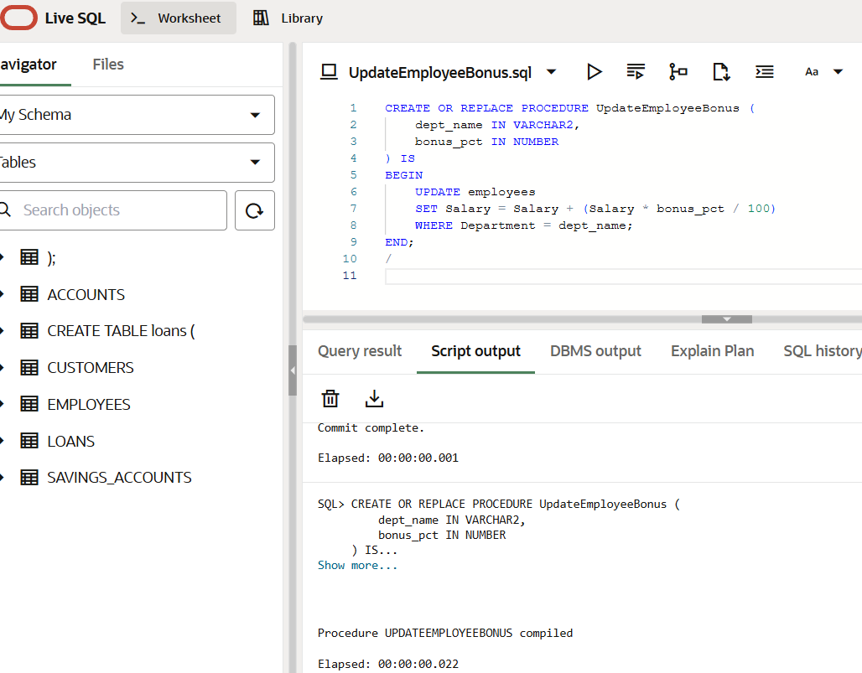

**5.Transfer Funds:**

BEGIN

    DBMS_OUTPUT.PUT_LINE(' Final Account Balances ');

    FOR acc_rec IN (SELECT * FROM bank_accounts ORDER BY BankAccountID) LOOP

        DBMS_OUTPUT.PUT_LINE(

            'Account ID: ' || acc_rec.BankAccountID ||

            ', Holder ID: ' || acc_rec.HolderID ||

            ', Balance: ₹' || acc_rec.AccountBalance

        );

    END LOOP;

END;

/

**Output:**

